* Docker compose is a tool where we can describe multiple microservices in single yaml file
* Usually we use this to setup dev or test environment
* Docker compose is used to for defining and running multi container applications

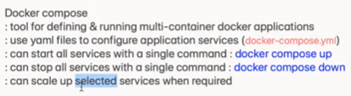

In windows & mac, docker compose gets installed along with docker

* **Docker-compose -v or docker-compose version** 🡪 **to check the version of docker compose**
* **Sudo apt install docker-compose** 🡪 **to install on ubuntu**

Create a file as docker-compose.yml

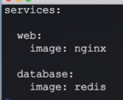

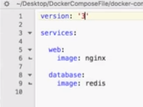

Mention as above with the image’s names inside yaml file

* **Docker-compose config** 🡪 **to validate the yml file**

Once the validation is done, we can run compose as below

* **Docker-compose up -d** 🡪 **to run the yml file**

-d means detached mode

After this, we can see the two-container running

And if we want to down the containers, we can do it with below command

* **Docker-compose down**

From docker hub, we can see the compose file of any image, we can many things in compose file like port, etc

If we want to scale any service, we can do as below

* **Docker-compose up -d - -scale database=4**

After running this, it will create 4 database services which we have mentioned in yaml file